# 6 Performance Management

How Can I Use Goals, Feedback, Rewards, and Positive Reinforcement to Boost Effectiveness?

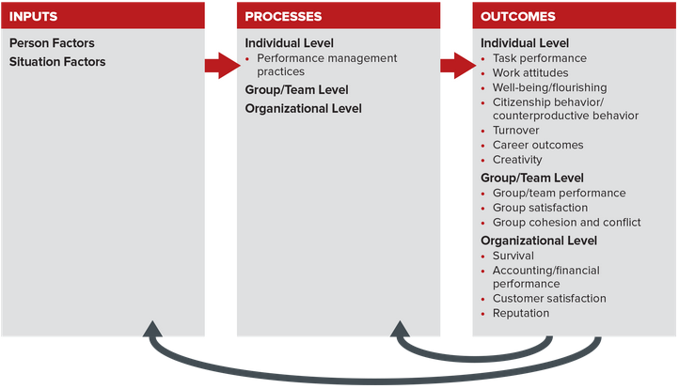

## 6.1 Performance Management Processes.

Performance management (PM) is a set of processes and managerial behaviors that include defining, monitoring, measuring, evaluating, and providing consequences for performance expectations. Defined in this way, PM is far more than performance appraisal. Appraisals typically consist only of the actual performance review, an event. Effective PM, in contrast, is a continual process and a critically important individual-level process. Performance management typically operates through an organization’s managers and human resources policies and practices. You will learn how it affects outcomes across all levels in the Organizing Framework, such as individual (job satisfaction, OCBs, and turnover), team (cohesiveness, conflict, and performance), and organizational (reputation, performance, survival, innovation, and employer of choice).

Effective Performance Management,

As illustrated in Figure 6.2, effective PM has four steps:

Step 1: Defining performance.

Step 2: Monitoring and evaluating performance.

Step 3: Reviewing performance.

Step 4: Providing consequences.

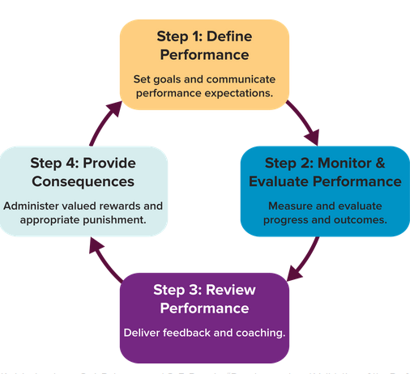

Successfully managing performance is a powerful means for improving individual, group/team, and organizational effectiveness. Effective performance management influences important outcomes such as greater employee engagement and betterPage 204 organizational performance. Managers who practice effective performance management generate exceptional results compared to those who don’t:

48% higher profitability.

22% higher productivity.

30% higher employee engagement scores.

17% higher customer engagement scores.

19% lower turnover.

Common Uses of Performance Management

Most performance management processes have three primary functions.

(1) Make employee-related decisions. Your performance can be used to justify a pay raise, a promotion, and new assignments. PM can also generate documentation to help justify termination and reduce the chances of a wrongful dismissal lawsuit.

(2) Guide employee development. Effective performance management helps identify employees’ strengths, weaknesses, and development needs. One performance management expert said that PM “is one of the most powerful talent management practices we have as HR professionals.”8

(3) Signal desired employee behavior. Performance management processes signal and otherwise communicate what is expected from employees, such as job performance and career advancement.

What Goes Wrong with Performance Management,

First, performance management practices are often obsolete. Customer needs and job responsibilities change frequently and quickly, but PM practices often fail to keep pace. This can result in a disconnect between the elements in your review and what you actually do day-to-day in your job. This can reduce the whole process to “chores” that require little more than checking boxes.

Second, PM is time consuming. Some surveys report that managers spend on average 210 hours per year on PM activities. That equals 5.25 weeks, or more than a month! It is even more difficult to justify the time when 77 percent of HR executives feel their reviews do not accurately capture employee contributions.

Third, performance reviews are too narrow. This means managers administering them commonly focus on only a limited number of elements, which may not be the only or the most important ones. One reason for this narrow scope is that many companies include only what is measured instead of what should be measured. For example, law firms may say they want and need attorneys to focus on client service and community involvement, but the only thing they measure and link to rewards is billable hours with clients. This is largely what they get.

The Importance of Management and Leadership,

Performance fluctuates widely and unnecessarily in most companies, in no small part from a lack of consistency in how people are managed. Research consistently shows that over half of the most important drivers of employee engagement and performance are precisely the behaviors that define effective performance management: setting clear expectations, helping employees accomplish work, providing regular feedback, and finding new opportunities for employees to succeed and develop. This means that managing performance successfully requires that you have effective managers. PM policies and practices cannot substitute for poor management, yet effective managers can be undermined by poor PM policies and practices.

## 6.2 Step 1: Define Performance—Expectations and Goals,

Do You Want to Perform or Learn?

One way to organize or differentiate your many goals is to categorize them as performance or learning. A performance goal targets a specific end result, and a learning goal promotes enhancing your knowledge or skill. Managers typically overemphasize the former and ignore the latter as they try to motivate greater effort and achieve results.

Managing the Goal-Setting Process

There are four general steps to follow when implementing a goal-setting program (for yourself or others). Deficiencies in one step cannot be made up for with strength in the others. You need to diligently execute all four steps. We label these Step A, Step B, and so on to avoid confusion with the numbered steps of the effective performance management system (compare Figure 6.2).

Step A: Set goals.

Step B: Promote goal commitment.

Step C: Provide support and feedback.

Step D: Create action plans.

Step A: Set Goals,

Whether your manager sets your goals or you set them together, the goals should be “SMART.” SMART applied to goals is an acronym for specific, measurable, attainable, results oriented, and time bound. Table 6.1 lists practical guidelines for writing SMART goals.

Step B: Promote Goal Commitment,

Goal commitment is important because employees are more motivated to pursue goals they view as personally relevant, obtainable, and fair. Table 6.2 provides practical advice to increase your goal commitment, while at the same time improving the quality of your goals and boosting your likelihood of success.

Step C: Provide Support and Feedback,

This step is about helping employees achieve their goals. (More detail related to feedback is provided later in this chapter.) Practical suggestions include:

Make sure each employee has the necessary skills and information to reach his or her goals. Provide training if necessary, because it can boost people’s expectancy (Chapter 5).

Similarly, pay attention to employees’ expectations about their perceived relationship between effort and performance (recall expectancy theory from Chapter 5), their perceived self-efficacy, and their reward preferences, and adjust accordingly.

Give employees timely and task-specific feedback (knowledge of results) about what they are doing right and wrong.

Provide monetary and nonmonetary incentives, and be sure to reward meaningful progress and not just goal accomplishment.

Step D: Create Action Plans,

The first three steps all help tremendously in formulating your actions plans. Table 6.2 also offers useful tips. Besides these, we encourage you to look to your experience—what’s worked in the past when pursuing a similar goal? If you can’t rely on your own experience, then learn what others have done and follow their plan. No need to reinvent the wheel.

Next, visualize what achieving the goal looks like and work backward. This is another instance when the characteristics of SMART goals are extremely valuable. Being specific, results oriented, and time bound are fundamental characteristics of solid action plans. Finally, if you run into difficulties, we’ve already provided you with an excellent tool—the 3-Step Problem-Solving Approach. This can help you identify and remedy roadblocks in your goal setting and action plans.

Applying a contingency approach to goal setting is another way to be more effective and boost performance. Let’s explore this next.

Contingency Approach to Defining Performance and Setting Goals,

Learning and performance goals have their place, and setting SMART goals can give you a significant advantage over your competitors. However, another way to define goals is in terms of behavioral, objective, and task/project (see Table 6.3). Defining goals in this manner helps you assure your goals match the situation. For instance, not all performance can or should be defined and measured in dollars and cents.

## 6.3 Step 2: Performance Monitoring and Evaluation,

Monitoring Performance—Measure Goals Appropriately and Accurately

Monitoring performance means measuring, tracking, or otherwise verifying progress and ultimate outcomes. You use the information gathered through monitoring to identify problems (and successes) and to find opportunities to enhance performance during the pursuit of a goal. To be effective, you need to use or even create accurate and appropriate measures. Table 6.3 showed that many goals can be categorized as behavioral, objective, or task-oriented. The way you measure these goals should match their character.

Your measurement and monitoring can improve further still if you consider the following (you’ll notice some overlap with Table 6.3):

Timeliness. Was the work completed on time? Many customer service roles require representatives to answer calls within a certain number of rings, or to respond to customer requests in a certain number of hours or days.

Quality. How well was the work done? A behavioral goal that could fit here is greeting customers warmly, personally, and with a smile. Measurement consists of observing and/or reporting that these actually occurred.

Quantity. How much? Sales goals are common examples here, such as dollars or number of units sold.

Financial metrics. What are the profits, returns, or other relevant accounting/financial outcomes? For instance, some law firms measure the performance of attorneys and the larger firm by calculating profits in dollars per partner.

Monitoring Performance—Measure Goals Appropriately and Accurately

Monitoring performance means measuring, tracking, or otherwise verifying progress and ultimate outcomes. You use the information gathered through monitoring to identify problems (and successes) and to find opportunities to enhance performance during the pursuit of a goal. To be effective, you need to use or even create accurate and appropriate measures. Table 6.3 showed that many goals can be categorized as behavioral, objective, or task-oriented. The way you measure these goals should match their character.

Your measurement and monitoring can improve further still if you consider the following (you’ll notice some overlap with Table 6.3):

Timeliness. Was the work completed on time? Many customer service roles require representatives to answer calls within a certain number of rings, or to respond to customer requests in a certain number of hours or days.

Quality. How well was the work done? A behavioral goal that could fit here is greeting customers warmly, personally, and with a smile. Measurement consists of observing and/or reporting that these actually occurred.

Quantity. How much? Sales goals are common examples here, such as dollars or number of units sold.

Financial metrics. What are the profits, returns, or other relevant accounting/financial outcomes? For instance, some law firms measure the performance of attorneys and the larger firm by calculating profits in dollars per partner.

Perceptual Errors in Evaluating Performance,

As you learned in Chapter 4, your attributions and perceptions can greatly influence the way you evaluate the information you gathered via monitoring. Table 6.4 lists common perceptual errors in monitoring employee performance and recommended solutions.

In 360-degree feedback individuals compare perceptions of their own performance with behaviorally specific (and usually anonymous) performance information from their manager, subordinates, and peers. Such multi-rater feedback can also come from outsiders, such as customers or suppliers.

## 6.4 Step 3: Performance REVIEW, Feedback, and Coaching,

What Effective Feedback Is … and Is Not

Students and employees alike appreciate feedback (at least those who are top performers do). Both want to know how they’re doing and how their performance compares to that of their peers. Feedback is an important, but not always present, cousin of goal setting. It enables you to learn how your performance compares to the goal, which you can then use to modify your behaviors and efforts. We therefore define feedback as information about individual or collective performance shared with those in a position to improve the situation.

Effective feedback is only information—it is not an evaluation. Subjective assessments such as “You’re lazy” or “You have a bad attitude” do not qualify as effective feedback. They are simply opinions and often have little value. But hard data such as units sold, days absent, dollars saved, projects completed, customers satisfied, and quality rejects are all candidates for effective feedback. Christopher Lee, author of Performance Conversations: An Alternative to Appraisals, clarifies the concept of feedback by contrasting it with performance appraisals:

Two Functions of Feedback,

Experts say feedback serves two functions for those who receive it: one is instructional and the other motivational. Feedback instructs when it clarifies roles or teaches new behavior. For example, an assistant accountant might be advised to handle a certain entry as a capital item rather than as an expense item. Feedback motivates when it serves as a reward or promises a reward (remember the discussion in Chapter 5). Hearing the boss say, “You’ve completed the project ahead of schedule; take the rest of the day off,” is a pleasant reward for hard work. More generally, however, many employees appreciate the attention and interest expressed by the very act of providing feedback, regardless of content.

Important Sources of Feedback—Including Those Often Overlooked

The three common sources of feedback are,

1. Others,
2. Task,
3. Self.

The Role of Senior Managers and Leaders

Nobody likes to give the boss negative feedback. And frankly, many bosses never ask for feedback because they don’t want it. For example, one of the authors has worked at multiple universities and companies in various industries, and none of his bosses have solicited feedback—not deans, not department chairs, not executives, not managers—no one. Another problem is that task feedback is less feasible for senior managers because their day-to-day activities are more abstract than those of frontline employees (for instance, formulating strategy versus closing a sale). The predicament for companies is consequential, as noted by Jim Boomer, a CPA and professional service firm consultant:

If you don’t have a system for holding individuals accountable for their goals, all the work, time, and effort that goes into developing these plans is diminished and you’ve your wasted effort.… Leadership tends to hold junior employees accountable but shies away from a formalized system to measure performance at the [senior manager/leader] level.… If [senior managers/leaders] are not willing to hold themselves accountable, employees will simply go through the motions and won’t buy into a firm-wide performance system.

They can seek feedback from others by creating an environment in which employees feel they can be honest and open.

Separating feedback from the performance review process also helps, especially for executives who typically are reviewed informally if at all.

They can create a mechanism to collect feedback anonymously. This is useful if the source of the feedback is not particularly important. For example, a CEO based at headquarters in Phoenix is curious about how she is perceived by the design team in Shanghai. In this instance, she doesn’t need to know the views of any specific employee, just the views of employees from that location.

Exit and Stay Interviews,

Employees quit jobs for many reasons, such as better job opportunities, dual-career issues, money, lack of fairness, bullying, and the most common—a horrible boss. Whatever the reason, exit interviews can provide the feedback that uncovers the true reasons.

Exit interviews are an excellent means for obtaining feedback regarding reasons employees leave. More recently, some companies also are conducting stay interviews. The reasoning is simple—find out why people stay and do things to keep them. It is far more effective and cheaper to keep good employees than to replace them.

When done well, exit interviews can:52

Build employee engagement. Collecting, sharing, and acting on the information gained signals to remaining employees that their views and experiences matter. This in turn can foster engagement.

Highlight needed action. Because poor management is a common cause of turnover, exit interviews can help pinpoint development needs for managers, such as help for those who tend to micromanage.

Help benchmark. Exiting employees often can reveal pay and benefits packages of competitors, as well as other factors that make them attractive to key talent.

Make former employees into recruiters. Providing exiting employees an opportunity to share opinions and experiences can build goodwill in their eyes. Favorable opinions may lead departed employees to recommend their former employer to friends and associates as a good place to work or do business.

Make former employees into customers or partners. Depending on the nature of the business, former employees may become or remain customers of their past employer’s products or services. They may also partner and actually work together. In both cases the former employer wins. For instance, many attorneys leave law firms and go “in house” to work for clients. They then hire the law firm for legal services.

Factors that Affect Your Perceptions of Feedback

Many factors influence the way we perceive feedback. For instance, all managers and employees are susceptible to the fundamental attribution bias (your manager attributes your poor performance entirely to you and things you control) and the self-serving bias (you are likely to take credit for positive performance outcomes and attribute poor performance to extrinsic factors). The following also can influence your perceptions of feedback:

Accuracy. A common criticism of PM systems is that they measure the wrong things or measure the right things the wrong way. Either way, the feedback is inaccurate.Page 226

Credibility of the sources. If a member of your project team points out shortcomings in your work, you are likely to put more weight on the feedback if he or she is an “A” student or top performer. Trust is also critical here. If you don’t trust the person delivering the feedback, you will likely be suspicious of his or her intentions and discount its value.

Fairness of the system. If you perceive the process or outcomes—recall equity theory from Chapter 5—as unfair, you are likely not only to discount the feedback but also to be outraged, withdraw, commit counterproductive work behaviors, and/or quit. Performance appraisals are one of the aspects of organizational life that most commonly reveal issues of fairness.

Performance-reward expectancies. Effective performance management, particularly ongoing and open feedback between you and your supervisors, is an important means of managing such expectancies.

Reasonableness of the goals or standards. When it comes to goals, challenging is good, unattainable bad. If your manager says, “You can earn a bonus of up to 50 percent of your salary,” ask whether anybody has actually ever earned that much. If not, you may be the first, but more likely the goal is unreasonable.

Any feedback that fails to clear one or more of these cognitive hurdles will be rejected or discounted. Personal experience largely dictates how you weigh these factors. For example, a review of research on disciplinary practices found that people have different perceptions of a disciplinary act based on the gender of the person delivering the discipline, the cultural characteristics of the people involved, and the supervisor’s use of apologies and explanations. Given these differences in perception, we recommend that supervisors utilize two-way communication, follow up with the employee to make sure the discipline was understood, use empathy (or apologies if appropriate) to lessen the employee’s negative reactions, and focus on helping the employee in the long run.

Negative Feedback,

Remember, feedback itself is simply information. It becomes positive or negative only when you compare it to a goal or expectation. Such comparisons are the basis for improvement. (Note: Negative feedback is not negative reinforcement. You’ll learn the important difference later in this chapter.) Generally, people tend to perceive and recall positive feedback more accurately than they do negative feedback. But negative feedback (such as being told your performance is below average) can have a positive motivational effect. One study showed that those who were told they were below average on a creativity test subsequently outperformed those who were led to believe their results were above average. The subjects apparently took the negative feedback as a challenge and set and pursued higher goals. Those receiving positive feedback were less motivated to do better.

Nonetheless, feedback with a negative message or threatening content needs to be administered carefully to avoid creating insecurity and defensiveness. Put another way, perception matters. Both negative and positive feedback need to provide clear guidance to improve performance. Feedback is most likely to be perceived accurately, and thus more likely to be acted on, when it is instructional and helps achieve an important or valued outcome. Table 6.6 provides guidance for using negative versus positive feedback.

Table 6.6 when to use positive AND negative feedback

Positive feedback best when receiver is,

1. Near beginning of pursuing a goal,
2. A novice
3. A distant relationship

Negative feedback best when receiver is

1. Near end of pursuing a goal
2. An expert
3. A close relationship

Self-efficacy also can be damaged by negative feedback, as discovered in a pair of experiments with business students. The researchers concluded, “To facilitate the development of strong efficacy beliefs, managers should be careful about the provision of negative feedback. Destructive criticism by managers which attributes the cause of poor performance to internal factors reduces both the beliefs of self-efficacy and the self-set goals of recipients.”58 Managers therefore need to be careful when delivering feedback, due to the effect of feedback on goals.

Feedback Do’s and Don’ts,

According to Anne Stevens and Greg Gostanian, principal consultants at ClearRock, an outplacement and executive coaching firm, “Giving feedback to employees—and receiving feedback yourself—is one of the most misunderstood and poorly executed human resource processes.”59 Table 6.7 lists important and fundamental do’s and don’ts for giving feedback.

Coaching—Turning Feedback into Change,

Coaching is a customized process between two or more people with the intent of enhancing learning and motivating change. Coaching can occur at any step in the PM process, but it most often follows the review and consequences of performance.

Effective coaching is developmental, has specific performance goals, and typically includes considerable self-reflection, self-assessment, and feedback. In fact, “research from Gallup, McKinsey, and Harvard recommends that giving feedback should be the most used tool in a coach’s toolbox.” The Self-Assessments throughout this book can serve as important elements for your own coaching. When approached in this way, coaching is not only an important aspect of effective performance management, but it is also consistent with positive organizational behavior. Consider this: If coaching is done in the way described, who wouldn’t appreciate it or benefit from it?

## 6.5 Step 4: Providing Rewards and Other Consequences

Key Factors in Organizational Rewards

Despite the fact that reward systems vary widely, they do share some common components. The model in Figure 6.3 diagrams the relationship of three components:

1. Types of rewards,
2. Distribution criteria,
3. Desired outcomes.

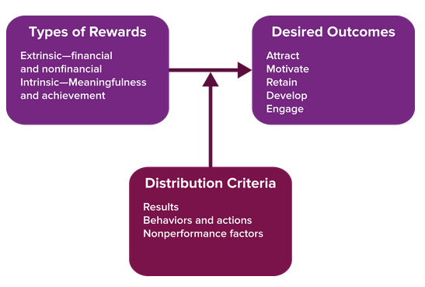

Types of Rewards

Financial, material, and social rewards qualify as extrinsic rewards because they come from the environment. Psychic rewards, however, are intrinsic rewards because they are self-granted. If you work primarily to obtain rewards such as money or status, you are extrinsically motivated. If you derive your primary reward from the task itself, or the feeling that your work is meaningful and gives you a sense of responsibility, then you are motivated by intrinsic rewards (recall extrinsic and intrinsic motivation from Chapter 5).

The relative importance of extrinsic and intrinsic rewards is a matter of culture and personal preferences, so it is critically important to know what types of rewards you and others value most. This knowledge can make the difference in your getting what you want personally, as well as in your ability to effectively manage others. It can also assist you in identifying employers with whom you fit.

Distribution Criteria

Organizations use three general criteria for distributing rewards:

1. Results. Tangible results include quantity produced, quality, and individual, group, or organizational performance. These are often accounting-type measures—sales, profit, or error rate. Employers increasingly include customer satisfaction.
2. Behavior and actions. Examples are teamwork, cooperation, risk taking, and creativity.
3. Nonperformance considerations. Examples are abundant, such as rewards linked to seniority or job title. Associate attorneys’ salaries are often linked to the number of years out of law school—first-year associates get paid a set salary, which differs from second-year associates, and so on. Night or weekend shifts often pay differently. Perks, like use of a company plane or membership to a golf club, often received by executives are nonperformance rewards. They get them just because they hold the job not because of what they do.

Desired Outcomes of the Reward System,

As Figure 6.3 showed, a good reward system should not only attract and motivate talented people, but it should also foster development and keep talented people from leaving. APage 232 prime example is Tulsa-based QuikTrip, a gas station and convenience store chain. Good employee wages and benefits, training, and a friendly and supportive culture result in an annual turnover rate of just 13 percent. The industry average is 59 percent! An employee was quoted as saying, “We actually have to open new markets to create movement to give our employees an opportunity to advance because no one leaves.” No wonder QuikTrip made Fortune’s list of Best Companies to Work For (especially for Millennials).

Be Sure You Get the Outcomes You Desire,

And as we’ll explore, rewards come in many forms—financial and nonfinancial. But whatever the case, whoever provides the reward should get what is desired or intended in exchange. There are three potential outcomes from rewards:

1. Desired outcome. You get more of what you intended and for which you are rewarding people.
2. Nothing. The reward can have no effect.
3. Undesired side effects. Rewards reinforce or motivate the wrong behaviors.

A report by the Society for Human Resource Management describes the current and broader perspective that is “total rewards.” Total rewards encompass not only compensation and benefits, but also personal and professional growth opportunities and a motivating work environment that includes recognition, job design, and work–life balance. Table 6.8 lists and describes the key components of a total rewards perspective.

Alternatives to Money and Promotions,

McKinsey Consulting found that three noncash rewards were at least as effective as monetary rewards such as cash bonuses, increased pay, and stock options. Those rewards are:

1. Praise from immediate managers (e-mail or handwritten notes, recognition in meetings).
2. Attention from leadership (one-on-one conversations with top leaders, lunch).
3. Opportunities to lead projects or task forces (such as for new products, new practices, or market research).

How to Boost the Effectiveness of Rewards,

One step that can improve the effectiveness of almost any reward system is involving employees in devising the system. Recall the discussion of motivation and procedural justice in Chapter 5. Including them in the design, selection, and assessment of rewards programs increases the chance that employees will perceive the rewards as fair and valuable. (Valuable rewards are valence outcomes in expectancy theory from Chapter 5.) Involvement also fosters employee engagement—discussed in Chapter 2—because it makes them feel valued.

Pay for Performance

Pay for performance is the popular term for monetary incentives that link at least some portion of pay directly to results or accomplishments. Pay for performance is compensation above and beyond basic wages and salary, and its use is consistent with recommendations derived from the expectancy theory of motivation. Many people refer to it simply as incentive or variable pay, which has consistently grown as a percentage of total compensation for decades. This means that over the course of your career, an increasing portion of your pay will be variable.

The general idea behind pay-for-performance schemes—including but not limited to merit pay, bonuses, and profit sharing—is to give employees an incentive for working harder and/or smarter. Supporters of incentive compensation say something extra is needed because hourly wages and fixed salaries do little more than motivate people to show up and put in the required hours. We look next at the types of pay for performance.

Making Pay for Performance Work,

As in all other OB topics, we can use research and practice as a guide. Monetary rewards can work if they help people meet their basic needs, confer status, or allow people to provide for their families.

However, monetary rewards do not increase knowledge, skills, and abilities, nor do they enrich jobs or enhance intrinsic motivation. Research shows mixed outcomes for pay for performance—sometimes increased performance results and sometimes decreased performance. A comprehensive review of the literature found only a modest positive relationship between financial incentives and performance quantity, and no impact on performance quality. The results are especially unimpressive for executive performance. Only a weak link was found between large executive bonuses paid out in good years and improvement in corporate profitability in subsequent years.

## 6.6 Reinforcement and Consequences,

The Law of Effect—Linking Consequences and Behaviors,

During the early 1900s, psychologist Edward L. Thorndike observed in his lab that a cat would behave randomly when placed in a small box with a secret trip lever that opened a door. However, once the cat had accidentally tripped the lever and escaped, it would go straight to the lever when placed back in the box. Hence, Thorndike formulated his famous law of effect, which says behavior with favorable consequences tends to be repeated, while behavior with unfavorable consequences tends to disappear. This was a dramatic departure from previous notions that behavior was the product of instincts.

Using Reinforcement to Condition Behavior,

Skinner labeled unlearned reflexes or stimulus–response (S–R) connections respondent behavior. This category of behavior describes a very small proportion of adult human behavior, like shedding tears while peeling onions and reflexively withdrawing your hand from a hot stove.

Skinner attached the label operant behavior to behavior learned when we “operate on” the environment to produce desired consequences. Some call this view the response–stimulus (R–S) model. Years of controlled experiments with pigeons in “Skinner boxes” led to the development of a sophisticated technology of behavior control, or operant conditioning.

Contingent Consequences

According to Skinner’s operant theory, contingent consequences control behavior in one of four ways:

1. Positive reinforcement,
2. Negative reinforcement,
3. Punishment,
4. Extinction

The term contingent here means there is a purposeful if-then link between the target behavior and the consequence. So you should first think of the target behavior and whether you want to increase or decrease it, and then choose the appropriate consequence (see Figure 6.4). We next look more closely at the four behavioral controls.

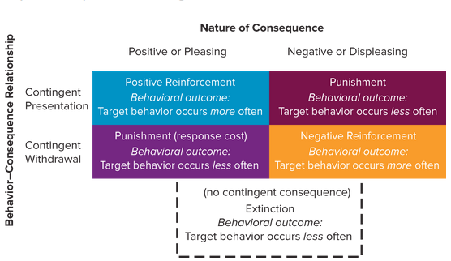

Increase Desired Behaviors

Positive reinforcement is the process of strengthening a behavior by contingently presenting something pleasing. A behavior is strengthened when it increases in frequency and weakened when it decreases in frequency. For instance, in the wake of the BP oil spill in 2010, newly appointed CEO Bob Dudley based 100 percent of employees’ variable pay (bonuses) on safety for the fourth quarter of 2010. This was a reward or reinforcer for safe behaviors.

Negative reinforcement also strengthens a desired behavior by contingently withdrawing something displeasing. For example, many probationary periods for new hires are applications of negative reinforcement. During probation periods (often your first 30, 60, or 90 days on a new job) you need to have weekly meetings with your boss or have somebody sign off on your work. Once you’ve demonstrated your skill, these requirements are removed.

Decrease Undesired Behaviors

Punishment is the process of weakening behavior through either the contingent presentation of something displeasing or the contingent withdrawal of something positive. The U.S. Department of Transportation now fines airlines up to $27,500 per passenger for planes left on the tarmac for more than three hours. This policy reduced reported cases from 535 to 12 in the first year it was implemented.

And while approximately 69 percent of companies have employee health and wellness programs, and 75 percent of these use incentives, some companies are now punishing employees for unhealthy behaviors. CVS Caremark, for instance, now requires its employees to participate in health screenings or pay an extra $600 for their health care premiums.

This practice is supported by research at the University of Pennsylvania. The administrators offered different cash incentives for employee participation in “step programs,” with a goal that every employee should walk 7,000 steps per day. The incentives did not affect goal achievement any better than having no incentives. However, participants who would have been penalized for not walking 7,000 steps reached the goal 55 percent of the time. A related study produced similar results. Participants who were at risk of losing their $550 health insurance premium incentive for noncompliance with healthy behaviors were more successful than those that were rewarded for doing so.

Weakening a behavior by ignoring it or making sure it is not reinforced is referred to as extinction. Discouraging a former boyfriend or girlfriend by blocking phone calls or texts or unfriending the person on Facebook is an extinction strategy.

Positive Reinforcement Schedules,

You can supercharge or at least enhance the effectiveness of positive reinforcement (rewards) by managing the timing or schedule of reinforcement. Continuous and intermittent reinforcement schedules are two common means for timing the administration of reinforcers.

Continuous Reinforcement,

If every instance of a target behavior is reinforced, then a continuous reinforcement (CRF) schedule is in effect. For instance, if you get paid every time you make a sale, this is a CRF schedule. The sale is the desired behavior and payment is the reinforcement. CRF is especially useful for making early links between desired behaviors and outcomes, but they are susceptible to perceptions of entitlement and rapid extinction if the link is broken.

Intermittent Reinforcement,

Unlike CRF schedules, intermittent reinforcement consists of reinforcement of some but not all instances of a target behavior. There are four subcategories of intermittent schedules. Table 6.9 shows them along with examples.

Work Organizations Typically Rely on the Weakest Schedule,

Generally, variable ratio and variable interval schedules of reinforcement produce the strongest behaviors that are most resistant to extinction. As gamblers will attest, variable schedules hold the promise of reinforcement after the next roll of the dice, spin of the wheel, or pull of the lever. In contrast, continuous and fixed schedules are the least likely to elicit the desired response over time. Nevertheless, the majority of work organizations rely on fixed intervals of reinforcement, such as hourly wages and annual reviews and raises.

Reinforcement Schedules and Performance,

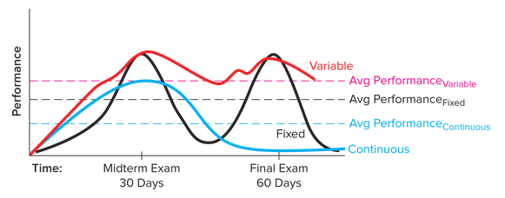

Practical Implications for Using the Strongest Schedule,

Variable Rewards/Bonuses. Entrepreneurs can especially benefit from applying knowledge of reinforcement schedules. Assume you started your own business and, like many new businesses owners, you are short on cash. You would like to provide regular bonuses and pay raises, but you can afford monetary rewards only when your company secures a new customer or a big order. The variable nature of these rewards not only recognizes employees’ efforts and success, but it also motivates them to work hard in the future because they know that such efforts are recognized and reinforced.